


THE REAL SCHOOLS
LEARNER’S EMPOWERMENT ACTIVITY
P.4 SCIENCE TERM 1 2025
TOPIC GROWING CROPS.

Golden Junior
School

Makindye Junior School

Victoria P/S
An excellent first grade and excellent character for every pupil

NAME……………………………………………… ………………………CLASS: ………………………….
SCHOOL: …………………………………………………………………………………………………..
THINNING. Is the removal of weak or overcrowded
seedlings from the garden or nursery bed.
examples of crops that need thinning.
Maize, cotton rice, millet, sorghum, carrots, eggplants, bananas etc
Methods of thinning
Uprooting/ digging out the plant
Cutting the plant at the base area.
Tools used for thinning
Panga hoe hands.
ADVANTAGES OF THININNG.
- It reduces competition for nutrients among crops.
- It gives enough space for other crops to grow bigger.
- Twined materials can be used for mulching.
- It controls the spread of crops pests
- It eases spraying.
- It improves the quality of yields.
- It controls the spread of crop diseases.
- It gives good space for weeding and harvesting.
MEGA ACTIVITY.
1. Define the term thinning.
_________________________________________________________________
2. Give any one examples of a tool used for thinning.
_________________________________________________________________
3. Tom is a farmer in bombo village. He wants to thin his crops Identify any two methods he can use to carry out thinning.
i) _____________________________ii) _________________________________
4. What can happen if farmers fail to thin their gardens
___________________________________________________________________
5. Why do farmers prune their crops? Give two reasons
__________________________________________________________________
b) Give any two examples of crops that can be pruned.
i) ________________________________ ii) _____________________________
6. Mention three advantages of thinning in plant growth
i) _______________________________________________________________
ii) _____________________________________________________________
iii) _____________________________________________________________
TEACHING PHASE 4.
WATERING
This is the act of supplying water to crops when there is less water in the soil
- It is done to prevent crops from drying and dying.
- Watering can also be done to newly transplanted seedlings.
- It is done using a watering can or horse pipe.
- A Sprinkler is used on large farms.
- It is done early in the morning and late in the evening daily
Reason there is little loss of water from the soil through evaporation in the evening and morning.
IIustrations showing watering
using a watering can using horse pipe
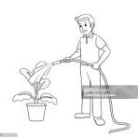
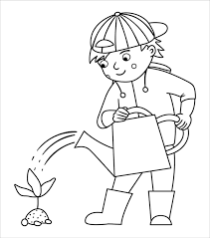

Uses of water in soil
- It makes the soil soft for roots to grow easily.
- Water helps in germination in photosynthesis
- It softens the ground for easy weeding.
- Cools the plants during transpiration.
MINI ACTIVITY.
1. What do you understand by the term watering.
___________________________________________________________________
2. Identify any two tools used for watering.
i) ________________________________ ii) ______________________________
3. At what time of the day are farmers advised to water their crops? Give four reasons
i) ___________________________________________________________________
ii) _________________________________________________________________
iii) ________________________________________________________________
iv) ______________________________________________________________
4. Why do farmers water their crops? Give four
i) __________________________________________________________________
ii) _________________________________________________________________
iii) _________________________________________________________________
iv) _________________________________________________________________
5. Give any situations that make farmers to water their crops.
__________________________________________________________________
CROP ROTATION.
This is the growing of different crops on some piece of land season after season.
Factors to consider when carrying out crop rotation.
- Legumes are rotated with other crop rotation more fertile since legumes add nutrients to the soil.
- Crops in the same family should not follow each other e.g maize and sorghum.
- Cover crops should be alternated with less vegetative leaf crops.
- Deep rooted crops to be rotated with shallow rooted crops which prevents the nutrients from getting used up at once.
- Crops easy to weed to be alternated with those difficult to weed.
- There should be resting phase.
IIIUSTRATION SHOWING CROP ROTATION CYCLE

 | Garden 1 | Garden 2 | Garden 3
First season | beans | maize | Cabbage
Second season | Cabbage | beans | maize
Third season | maize | cabbage | beans

Rotation through a single garden
Year 1 tomato
Year 2 beans
Year 3 carrots
Year 4
Heavy feeder
Heavy feeder
Light feeder

ADVANTAGES OF CROP ROTATION.
- It controls pests by breaking their life cycle.
- It keeps the soil fertile when legumes are included.
- It maintains soil fertility.
- It improves crop yields
- It controls crop diseases.
- It controls soil erosion.
- It controls the growth of weeds
MINI ACTIVITY.
1. what do you understand by the term crop rotation.
________________________________________________________________
2. Why should farmer use crop rotation as method of farming
__________________________________________________________________
3. When do farmers water their crops?
__________________________________________________________________
4. Identify any two items used for watering crops.
__________________________________________________________________
5. How is watering important to crops?
__________________________________________________________________
6. Identify four factors considered when carrying out crop rotation.
__________________________________________________________________
7. Give any four advantages of crop rotation.
_________________________________________________________________
8. Name the tool used for watering crops.
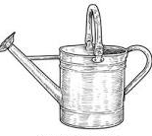

9. How does crop rotation control pests?
__________________________________________________________________
10. Using arrows and illustrations show how legumes cereals and vegetables can be rotated in three seasons.

Teaching phase 5
- Harvesting of crops.
- Harvesting is the collecting or removal of ready crops from agarden
- Harvesting should be done when the crops are ready.
- Most crops that need drying should be harvested in dry season to dry the harvest.
Note: Harvesting is done during the dry season because there is enough sun shine to dry the harvested crops.

Some garden tools used for harvesting

Tool | Purpose
Sickle | Harvesting cereal crops e.g millet and rice
Hoe | Harvesting root crops e.g cassava
Panga | Harvesting sugarcane, banana

Methods of harvesting crops
1. Cutting stems.
Here tools like panga, sickle and knives are used to cut the stem to get the harvested parts of the crop
Examples of crops harvested by cutting
Banana, sugarcane, millet, sorghum wheat, rice
2. Hands picking/plucking.
This is mainly used in crops with fruits or in cases where leaves are harvested like tea and leaf vegetables
Example of crops harvested by hand picking
Coffee, tomato, oranges, Eggplants, mango
3. Uprooting using hands
Examples of of crops harvested by uprooting using hands
Ground nuts, onions, carrots
4. Digging out the crop
This is used in crops with food stored in the roots or underground stems
Diagrams showing same of the methods of harvesting crops
Cutting the stem | Handpicking | Uprooting | Digging out
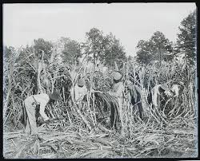 | 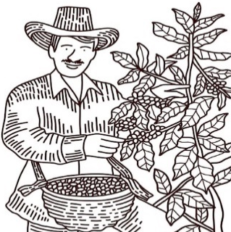 | 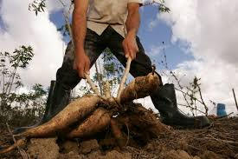 | 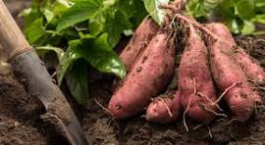
Disadvantages of early harvesting
- The seeds contain moisture so they may rot.
- The quality of seeds is poor.
- The grains are small and shrunk.
- The seeds will not good for planting.
Mega activity
1. What is meant by the term harvesting
__________________________________________________________________
2. Name any one example of a crop harvest by
a) hand picking______________________________________________________
b) Cutting___________________________________________________________
c) digging____________________________________________________________
d) Uprooting_________________________________________________________
3. Why do we harvest crops?
_________________________________________________________________
b) How is cassava harvested?
________________________________________________________________
4. Draw and name four the tools used for harvesting
5. Identify any four methods of harvesting crops.
__________________________________________________________________
__________________________________________________________________
__________________________________________________________________
__________________________________________________________________
6. Give any two crops that need to be harvested during dry season
i) _____________________________ ii) ________________________________
b) Which type of weather is suitable for harvesting leaf vegetables
________________________________________________________________
c) Name any two crops harvested using sickle.
i) ________________________________ ii) ___________________________
7. Mention any three disadvantages of early harvesting
________________________________________________________________
________________________________________________________________
________________________________________________________________
b) What causes rotting in harvested crops?
________________________________________________________________

Teaching phase 6
Storing crops
This is the keeping of harvested crops safe for furniture use
Ways of storing crops
Sun drying
Some crops are sun dried after harvesting
Sun drying removes water from the crops which prevent them from rotting
It also prevents them from being attacked by germs
Examples of crops that are sun dried before storage
- Grains e.g beans, ground nuts, coffee
- Sweet potatoes, cassava
Note
Perishable harvested crops can be stored in special structures with coolers
Non- perishable harvested crops can be stored in granaries, silos, sacks and stores
Reasons/ importance of storing food
- It prevents wastage
- It helps to get what to eat in the dry season.
- It helps farmers to sell their produce where here is good market
- It helps to have constant supply of food to eat.
- It helps farmers to keep what to plant in the next season.
PHASE 6
Materials used to store food
sacks, buckets, silos, pots refrigerators
Mani activity
1. Give the meaning of the tern food storage
________________________________________________________________
2. Why do farmers dry their harvested crops before storage?
_________________________________________________________________
3. Name this material used to store harvested crops
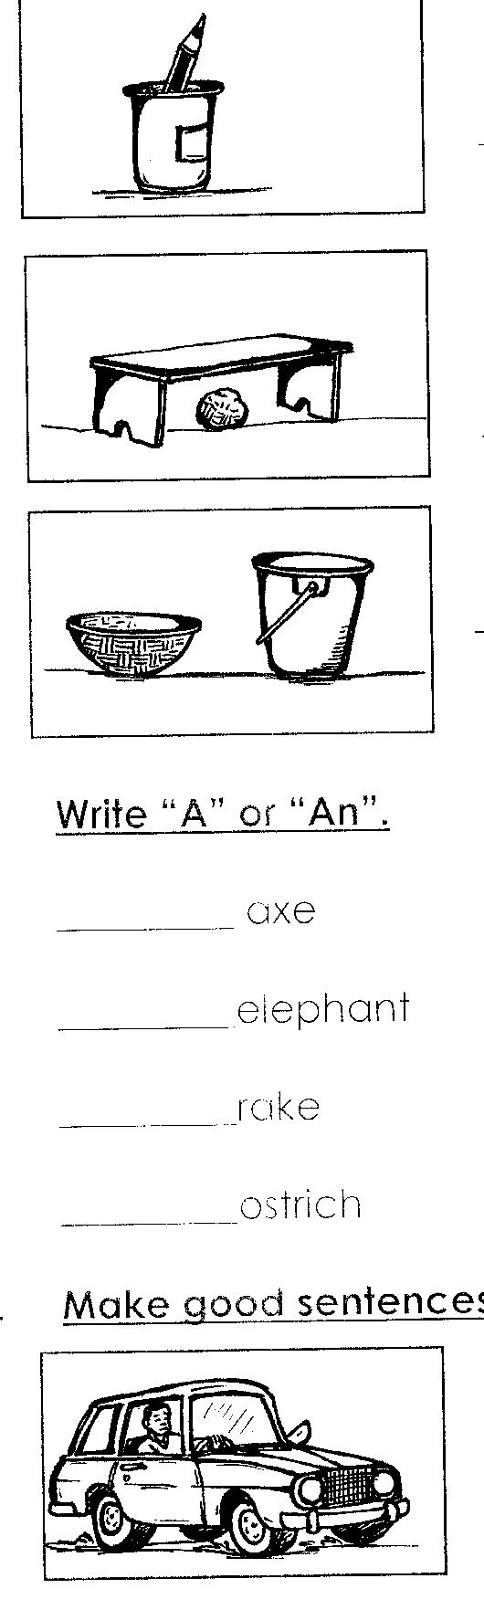 | 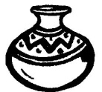

4. How is the sun useful to crop farmers during harvesting?
__________________________________________________________________
Ways of keeping food in the store
_ Here crops are packed in sacks and put in the store
_ There sacks should be placed on stands above the ground to prevent food from absorbing moisture from the floor.
Note
The moisture makes the food to get spoilt
ii) Using baskets and pots.
Here the food is put in baskets or pots with lids.
There are then placed on raise stands above the ground.
iii) Using baskets and pots.
Here buckets with lids are used to store good which prevents rats and insects from spoiling the food.
Places where food can be stored
_ Granaries
_ Silos
_ store/ houses
_ Freezers
Types of stores
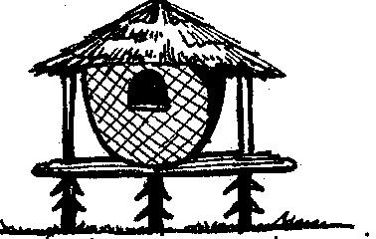
1. Traditional stores e.g granaries

2. Modern stores e.g silos
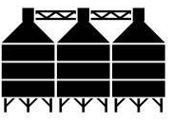

Qualities of agood store
- It should be well ventilated
- It should have rat guards
- The roof should be leak proof
- It should be clean and dry

Note
Rat guards prevent rats from entering the store.
Leak proof prevents dampness and rotting of the crops
Conditions for proper storage.
- The grains shoal be stored when they are dry.
- Tuber crops should be dried first before storing them.
- The roofs of stores should not leak
- Stores should have good ventilation
- The granary should have rat guards to prevent entry of rats
- The seeds should be dusted with pesticides to protect them from pests
Examples of storage pest
Rats, mice, maize weavils, bean ,Riceweavils
Storage beatles
Harvest mite
Mega activity
1. What is the meaning of the term food storage
_________________________________________________________________
2.Why do farmer dry their crops before storage.
___________________________________________________________________
3.Name this building where farmers keep their harvested crop
Rat guards
_________________________________________

4. How useful are rat guards on a storage house
_______________________________________________________________
5. Why should a storage house be dry.
________________________________________________________________
6. Apart from rats, give any one example of storage pests.
_______________________________________________________________
7. How should a farmer prevent weevils from attacking stored grains and seeds
______________________________________________________________
8. Give three places where crops can be stored.
_______________________________________________________________
b) What name is given to the modern store?
_______________________________________________________________
9a) How is moisture dangerous to store crops.
______________________________________________________________
b) Identify any three qualities of a good store.
i) ___________________ ii) ____________________ iii) ________________
10. Name any one material used to store perishable crops
______________________________________________________________
b) How why should a storage material have a lid?
________________________________________________________________
c) Give two reasons why a good store should have a leaf proof roof?
i) ______________________________________________________________
ii) _____________________________________________________________
SESSION THREE
Topic: Crop growing practices
Learning outcome: The learner will understand and describe crop pests and their examples.
Relevancy and functionality: The learner will be able to control crop pests in his / her home garden
Back ground knowledge: Wild animals
Session 29
Competences:
- Defines crop pests.
- Gives examples of crop pests plants affected.
- Gives effects of crop pests and signs of pest damage.
- States ways of controlling pests.
- Gives examples of crop diseases and plants affected.
- Gives signs of diseases damage on crops.
- Gives ways of controlling crop diseases
Crop pests
Crop pests are living organisms that affect/ damage crops.
Examples of crop pests
These pests are grouped into,
Field crops/ garden crops, pests.
Storage pests.
Examples of crop pests
Moles aphids
Rats Banana thrips
Mites worms
Weevils Termites.
Monkey

Study the table showing crops, pests and the affected plant part

Crops | Pests | Affected part.
Cassava | Green cassava mites, | Tips of cassava shoot
 | Mole rats | roots
Sweet potato | Weevil, squirrel, Eelworms, mole rats | roots
Irish potato | Aphids | Leaves.
Carrots | Worms | roots
Sugar cane | Stalk borers, aphids | Stems.
Banana | Banana thrips, weevils | Fruits, stem (corm)
Cabbage | Cut worm | Stem
Coffee | Mealy bugs | Leaves
Maize | Maize stalk borer | stems
 | Weaver birds, Termites | grains

Mini activity
1. What do you understand by the term crop pests
_______________________________________________________________
2. Write down any two examples of field crops.
i) ______________________________ ii) ____________________________
3. Name the part of sugar cane affected by aphids.
________________________________________________________________
Effects of crop pests
- They reduce on the crop yields.
- They lead to poor growth of crops.
- They weaken plant.
- They cause rotting of tubers due to damage.
- They reduce the quality of the yields.
Signs of pests damage in crops
- Holes in leaves.
- Seeds with holes.
- Rotten plant parts.
- Change of color in leaves
- Dark spots on the fruits.
Ways of controlling crop pests
These methods are categorized into.
Mechanical, biological and cultural methods of controlling crops pests and chemical methods.
Mechanical methods of pests control.
Physical guarding/ chasing the pests.
Fencing the garden to control big animals.
By trapping animals.
Putting scare crows in the garden.
Uprooting infected crops
Biological
Keeping animals that can feed on the pests. ( Use of natures enemies) keeping eats to kill rats
Keeping a dog to kill squirrels and moles
Cultural methods of controlling crops pests
- Through regular weeding
- By practicing crop rotation to break the life cycle of pests
- By planting pest free planting materials.
- Through proper spacing of the crops
Chemical control methods
By spraying crops with pesticides
By poisoning the pest
Mini activity
1. Mention any two example of crop pests.
i) ________________________ ii) _______________________________
2. Name any one ways of controlling crop pests?
____________________________________________________________
3. Name the crop pest drawn below.

4. How does crop rotation help to control crop pests in the garden?
________________________________________________________________
5. Mention any two effects of crop pests on the crops in the garden.
i) ________________________________________________________________
ii) _______________________________________________________________
Mega Activity.
1. Name one crop pest that affects the cassava roots
__________________________________________________________________
2. Mention any one mechanical method of controlling crop pests
___________________________________________________________________

3. How does crop rotation help to control pests in garden.
_________________________________________________________________
4. Mention any one danger of the crop pest drawn below
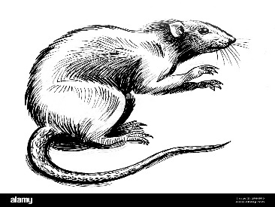

_______________________________________

5. Name any one animal kept at home to chase away rats.
__________________________________________________________________
6. Identify any one sign of pest damage in crops
___________________________________________________________________
7. How does spraying of crops using pesticides help to control crop pests in the garden.
__________________________________________________________________
8. What name is given to the living organisms that destroy farmer’s crops?
__________________________________________________________________
9. Mention any one chemical method of controlling crop pests
__________________________________________________________________
10. State any one importance of regular weeding in relation to pest control in a crop garden
__________________________________________________________________
Phase two
Competences
Defines farm records
Give example of records kept on a crop farm.
Gives importance of keeping records on a crop farm designing a farm record shed
Learning outcome.
The learner will be able to describe farm records, understand reasons for keeping farm records
Key Learning principle
Farm records are written information showing the different inputs and outputs on a farm
FARM RECODS
Farm records are written information showing the different activities done on a farm.
Examples of Records kept by crop farmers
Planting records
Harvesting records.
Pest and diseases control records.
Sales records
Inventory records
Activity
1. Give the meaning of the term farm records.
__________________________________________________________________
2. State any two examples of records kept by crop farmers.
_________________________________________________________________
__________________________________________________________________
3. How important are sales records to a crop farmer?
__________________________________________________________________
Importance of keeping records on a crop farm.
- Record helps the farmer to know whether the farm is making profits or losses.
- Records help the to identify areas that need improvement.
- Records help the farmer to Budget for the farm.
- They help a farmer to avoid repeating mistakes.
- They help a farmer to plan for the farm.
- They help to know the progress of the farm.
- Records keep the history of the farm

A farm records sheet.

Date | Crop planted | Date of weed controlled | Date manuring | Date harvest | Date of sale
3/7/2024 | Cassava | 4/8/2024 | 2/9/ 2024 | 10/10/2024 | 7/01/2025
Mini activity
1. In the space below, organize any one example of a farm record sheet from the date of planting to the date of harvest.
_________________________________________________________________
Mega activity
1. Mention any one example of records kept on a crop farm.
________________________________________________________________
2. Give the meaning of the term farm records.
_________________________________________________________________
3. How important is keeping farm records on a crop farm.
_________________________________________________________________
4. Give a reason why farmers keep health records on their crop farms
___________________________________________________________________
5. Name the activity taking place in the picture below.

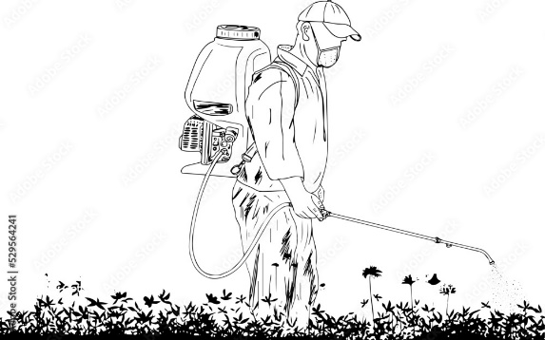

___________________________________

6. Why do people carry out the above activity?
__________________________________________________________________
7. Name any one crop pest that attacks the banana plants?
_________________________________________________________________
8. How does crop rotation help to control pests in your father’s garden
__________________________________________________________________

9. State any one sign of pest damage in crops.
________________________________________________________________
10. How dangers are rats on a cassava garden?
_________________________________________________________________
Research work.
Make brief notes about the storage facilities of harvested crops

Project work.
Using a piece of a box paper, illustrate a farm record sheet for health of your crops

